# Business Challenge

Field Technicians are overwhelmed with information from a variety of internal and external data sources. Often, there is a lack of effective methods to diagnose and resolve issues quickly out in the field. This impacts company operations and satisfaction and drives potentially poor use of parts and resources.

# Watson inspired solution to the problem

Today we can leverage the Watson Platform to engage field technicians directly with Watson over a simple interface including diagnosis and chat, connecting to current internal systems for specific data. This Watson pattern demonstrates how enterprises can enable their field technicians to get direct answers to their questions. This solution pattern is most applicable to the *Telecommunications, Electronics, Airlines, Media Companies, Energy Providers & Utilities industries.* Any industry with a large number of field technicians and truck rolls can leverage Watson Field Tech/Equipment Repair.

# Client discussion points

* How do your technicians perform in the field and how often do they need to escalate to command-center types of support?
* How often are multiple visits needed because an issue has resurfaced or because the root cause of the problem was not fixed?
* How often are parts replaced that may not be defective?
* Are you experiencing retirement or challenges in retaining your most knowledgeable technicians?

# Qualification Checklist

* How many technicians and truck rolls do they manage on a yearly basis?
* Are we engaged with the COO or CIO or VP of Service?
* Does the client have $250K to get started?
* Will the organization adopt Watson using their resources for development or do they need IBM Professional Services?

# Elevator pitch

**What is the client buying?**

* A 1-year subscription to Watson Explorer license and Watson Developer Cloud Platform which will enable the client to develop the Field Tech pattern

**How much does it generally cost and timeline?**

* $250K for a 1-year subscription & 4 weeks to deploy an initial pilot

**How does the solution get implemented?**

* There are two options:
* Self-Serve: 1-week enablement session for client developers with education on the solution pattern. After which, client IT teams then develop/deploy the solution in a self-serve mode.
* Professional Services: Leverage IBM or a systems integrator to develop

# Live Demo

[Field Service Advisor](http://fieldserviceadvisor.mybluemix.net/FieldServiceAdvisor/main.html)

Username: wfsa-demo

Password: wfs@

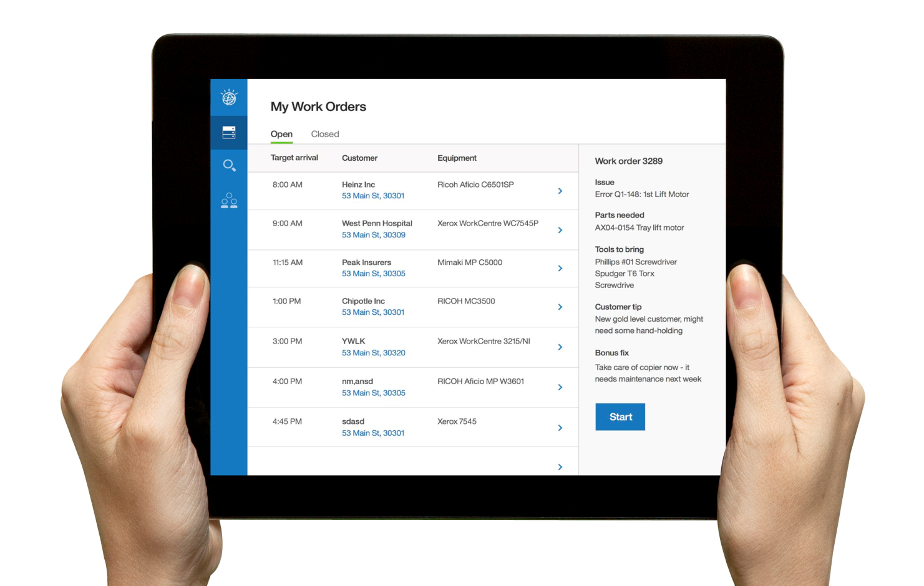

# KPI’s impacted

* Decrease repair visit duration
* Decrease cost/visit
* Decrease spare parts inventory needs and misused, unnecessary parts
* Increase process efficiency

# Target Buyer

* Chief Operating Officer
* Chief Information Officer
* VP Customer Service

## Competitive Differentiation

* Covers a previously under-served portion of the business process for technician support
* Makes each technician smarter and elevates organizational knowledge
* Step by step content reviews, ability to incorporate visual and audio interaction modes
* Diagnosis and Repair bundled together

|  |  |  |
| --- | --- | --- |
| Field Technician - Equipment Repair |  | Contact – Owen Coelho – occoelho@us.ibm.com |